24th November 2017

Finnian O’Neill

13430512

Scout Ahead

CA400 – Functional Specification

Table of Contents

Introduction 4

Overview 4

Business Context 4

Glossary 4

General Description 5

Product/System Functions 5

User Characteristics and Objectives 5

Operational Scenarios 7

USE CASE 1 7

Search for a route 7

USE CASE 2 8

Selecting a route 8

USE CASE 3 9

Search the weather for a given day 9

USE CASE 4 10

Downloading a route 10

Constraints 11

Speed constraints 11

Data Constraints 11

Accuracy Constraints 11

Time constraints 11

Functional Requirements 12

Use Cases 12

Search for a route 12

Selecting a route 12

Searching the Weather 13

Downloading the route 13

System Architecture 15

Architecture Diagram 15

Architrcture Components 16

Scout Ahead website 16

Libraries 16

Scout Ahead Database 16

Weather 16

OSM Database 16

High Level Design 17

Use Case Diagram 17

Description 17

Data Flow Diagram 18

Preliminary Schedule 19

Gantt Design 19

Proposed Schedule 19

Description of Tasks 20

Website Wireframe and Basic Components 20

OSM Integration & Map setup 20

Hostel & Transport Scraping 20

Study Break & Exams 20

Weather 20

GPX & Filters 20

Bug Fixing 21

Heatmaps 21

Accommadation Recommender 21

Additional Functionality 21

User Testing 21

Unit Testing & System Testing 21

Documentation 21

Study Break & Exams 21

Appendices 22

Libraries Used 22

Website Mockup 23

Layout 23

Map and More Info Panel 24

# Introduction

## Overview

Scout Ahead is a website that can be used as a planning tool for Walking and Scout Groups before they set out on their hike. Users will be able to Search an area for popular routes or enter a start point and finish point and see routes nearby or tailor existing routes to their needs.   
  
Users will also be able to check the weather, see what accommodation is nearby and much more. If users want more information on their route they can see a brief description of the route, elevation charts to see what will be the most challenging parts of the hike, approximate walking time, route distance and they can also download the route as a GPX file to be used with a GPS or mobile device.

The purpose of Scout Ahead is to allow hiking leaders to more efficiently plan routes and to gather as much information as possible before heading out on the trail.

## Business Context

The system will be primarily focused with Scout Groups in mind and as Scouting Ireland is a youth led organisation Scout Ahead will focus on highlighting the importance of the Scout motto, “Be Prepared”.

## Glossary

GPX - is an XML data format designed for lossless storage and transfer of data for GPS devices.

GPS – Global Positioning System.

OpenStreetMap – is the library that allows you to interact with the opensource maps.

OpenLayers – Is a library that gives extra functionality to OpenStreetMaps.

OpenGL – is a graphics library for more complex animations and imagery.

OpenWeatherMap – is an open source API that provides weather data to be used with maps.

# General Description

## Product/System Functions

* Search for a Route  
  Users will be able to search for routes a couple of different ways, either by entering in an area name into the search box, by navigating the map on screen or by entering a start and finish point.   
    
  Users will also be able to filter the results by route distance, level of difficulty and user uploaded routes. All routes will be clearly displayed on the left half of the screen, in a list format.
* Selecting a Route and Viewing more information  
  Once a route is selected, routes will be highlighted on the map where users can modify the route if they wish by dragging and adjusting the route highlighted on the map accordingly.   
    
  More information about the route will be displayed on the left side of the screen, this is where weather information, elevation graphs, walk time and finally where the route can be downloaded from.
* Download a Route  
  The final route will be available to download at a touch of a button in the GPX file format, which is the standard file format for GPS devices and can be read using many free mobile applications on both iOS and Android.
* Search the Weather  
  Searching the weather for your route on a given day can be done once your route has been selected. On the left side of the screen, the weather will be shown for the coming week.

## User Characteristics and Objectives

Scout ahead will be targeted to a broad range of users. Typical users have an invested interest in outdoor activities as they will be tasked with researching and preparing a route for the next outing. In Scouting Ireland, typically these users would be Teenagers (Scouts), Young Adults or Parents (Leaders) then outside of Scouting Ireland, Walking groups which have a large amount of retired.   
  
Each of these typical users pose different design challenges, some design attributes that apply to all demographics are a Simplistic and easy to navigate User Interface, with an intuitive and logical layout.   
  
Below are some sample users I have created to help me understand my demographic better.

## Operational Scenarios

|  |  |  |
| --- | --- | --- |
| USE CASE 1 | Search for a route | |
| **Goal in Context** | A user is able to search and find a suitable route | |
| **Scope & Level** | Subfunction, High Level | |
| **Preconditions** | The user must have an area, or a start/finish point in mind for the route | |
| **Success End Condition** | The user has a choice of routes to select | |
| **Failed End Condition** | No routes can be found | |
| **Primary,**  **Secondary Actors** | User  None | |
| **Trigger** | An area is entered in the search box or the user engages the map | |
| **DESCRIPTION** | **Step** | **Action** |
|  | 1 | User enters an area Name |
|  | 2 | A request is sent to the database |
|  | 3 | All routes in the area are displayed on the left side of the screen |
| **EXTENSIONS** | **Step** | **Branching Action** |
|  | 1a | User engages the map |
|  | 2a | Failed to retrieve results, error message is shown |
|  | 3a | No routes are displayed on the screen |
| USE CASE 2 | Selecting a route | |
| **Goal in Context** | A user can select a suitable route | |
| **Scope & Level** | Subfunction, High Level | |
| **Preconditions** | The user must have searched for a route | |
| **Success End Condition** | The user has selected a route | |
| **Failed End Condition** | A route cannot be found | |
| **Primary,**  **Secondary Actors** | User  None | |
| **Trigger** | A list of searched routes was returned | |
| **DESCRIPTION** | **Step** | **Action** |
|  | 1 | The user clicks on the desired route |
|  | 2 | The route is highlighted on the map |
|  | 3 | The more information window is displayed on the left side of the screen |
| **EXTENSIONS** | **Step** | **Branching Action** |
|  | 1a | User clicks on the wrong route |
|  | 2a | Failed to retrieve route, error is shown |
|  | 3a | Failed to retrieve route, no information is displayed, and error is shown |

|  |  |  |
| --- | --- | --- |
| USE CASE 3 | Search the weather for a given day | |
| **Goal in Context** | Retrieve weather forecast for given day | |
| **Scope & Level** | Subfunction, High Level | |
| **Preconditions** | The user must have selected a route | |
| **Success End Condition** | The user has viewed the weather for a chosen day | |
| **Failed End Condition** | No weather information available | |
| **Primary,**  **Secondary Actors** | User  OpenWeatherMap API | |
| **Trigger** | A list of searched routes was returned | |
| **DESCRIPTION** | **Step** | **Action** |
|  | 1 | User selects the given day from the list |
|  | 2 | A summary of the forecast is displayed |
|  | 3 | The map has weather information overlaid on it |
| **EXTENSIONS** | **Step** | **Branching Action** |
|  | 2a | No information is returned, error message is displayed |
|  | 3a | No information is returned, error message is displayed |

|  |  |  |
| --- | --- | --- |
| USE CASE 4 | Downloading a route | |
| **Goal in Context** | Selected route is downloaded as GPX file | |
| **Scope & Level** | Subfunction, High Level | |
| **Preconditions** | The user must have selected a route | |
| **Success End Condition** | The user has GPX file on selected route | |
| **Failed End Condition** | No file is downloaded | |
| **Primary,**  **Secondary Actors** | User  OpenLayers API | |
| **Trigger** | A list of searched routes was returned | |
| **DESCRIPTION** | **Step** | **Action** |
|  | 1 | User clicks the download button |
|  | 2 | The selected route is retrieved from the database |
|  | 3 | The route is converted to a GPX file |
|  | 4 | The GPX file Is downloaded |
| **EXTENSIONS** | **Step** | **Branching Action** |
|  | 2a | Communication error, no route is retrieved |
|  | 3a | A blank route is converted, error is displayed |
|  | 4a | No file is downloaded |

## Constraints

### Speed constraints

The search and retrieval of routes must be quick and efficient as to not frustrate users.

### Data Constraints

As there is no compiled list of Hostels, Bus Stops and Train Stations along with their Latitude and Longitude positions I will have to scrape this information from other sources. All of this information may not be possible to retrieve as not all websites allow scraping.

### Accuracy Constraints

The accuracy of the map, weather and navigation data is only as good as their sources and as such some basic testing to determine the accuracy of the data and a warning may need to be displayed on the website.

### Time constraints

Scout Ahead must be completed by May 2018. Time constraints may impact the scope of the project.

# Functional Requirements

## Use Cases

### Search for a route

**Description**

Users may use the search bar to search for an area, navigate the map or enter a start and finish location to search for nearby routes.

**Criticality**

This is a critical part of the website as all other parts rely on the information retrieved from the search.

**Technical** **issues**

As the search will be done dynamically any issues with any of the servers will cause the search to take much longer and may cause frustration for the user. As I won’t be hosting all the databases any issues with the other servers will be out of my control.

**Dependencies** **with** **other** **requirements**

Searching for a route is dependent on all the databases and servers being fully operational to retrieve the search results.

### Selecting a route

**Description**

Once the User has searched their area, all routes for the chosen area will be displayed on the left side of the screen in a list format for the User to pick one.

**Criticality**

Although not critical to the system, Users wishing to find out more information or to download the route must select the route first to proceed.

**Technical** **issues**

Technical issues may arise from retrieving the stored route data from the database.

**Dependencies** **with** **other** **requirements**

Selecting a route is dependent on Users searching an area first and if they wish to find out more information, download the route or search the weather they first must select the route.

### Searching the Weather

**Description**

Once a route is selected, Users may select a given day from the list to see a short summary of the weather for the given day and to overlay weather information on the map.

**Criticality**

Searching the weather is not critical to the system but more of a Wishlist item from a user’s perspective as the advantages of knowing what the weather has in store before you go may determine whether the trip will go ahead.

**Technical** **issues**

As all the weather information is being retrieved using the OpenWeatherMap API, any issues OpenWeatherMap has with their servers will affect the performance of my website. Lastly the accuracy of the weather information will also impact the Users experience as if it is inaccurate Users are less likely to use my website again.

**Dependencies** **with** **other** **requirements**

Searching the weather is entirely reliant on the OpenWeatherMap Servers as I will be using their API and Database to retrieve the weather information and as such any issues with their database or server will directly impact the performance of my site.

### Downloading the route

**Description**

Being able to download the route to your GPS is a key piece of functionality in the eyes of the User as it is the part of the route planning process that can be the most time consuming as Users usually must repeat the process of entering all the co-ordinates into the GPS once they have finalised the route.

**Criticality**

Although downloading the route is not system critical, it could be in the eyes of the User as not being able to do so adds quite a bit of extra time to the planning process.

**Technical** **issues**

Issues may arise when retrieving the route from the database as the database will be hosted by OpenStreetMaps and as such any issues with their service will impact my site. Also, if anything interrupts the conversion of the route to a GPX file the file may become corrupt.

**Dependencies** **with** **other** **requirements**

Downloading the route is dependent on routes being selected and Users hitting the download button.

# System Architecture

## Architecture Diagram

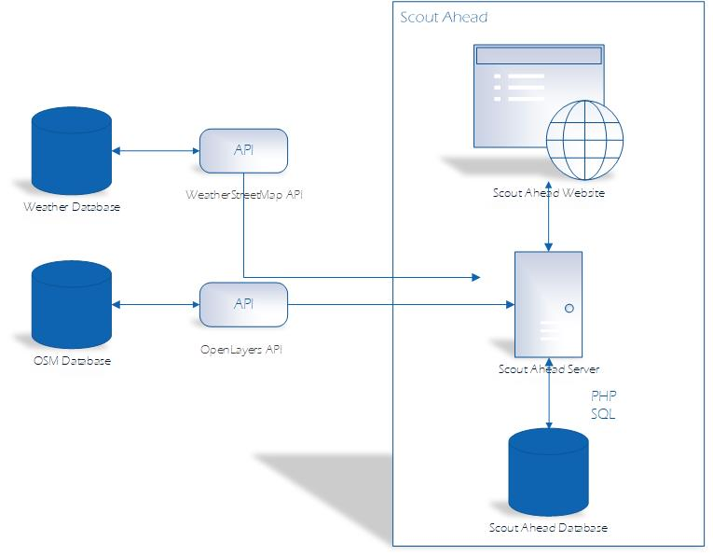

## Architrcture Components

### Scout Ahead website

The Scout Ahead website will be built using Angular2 and Bootstrap to make an easy to use dynamic User Interface.

### Libraries

The Scout Ahead website will use the OpenLayers, ChartJS and OpenGL libraries to interface with the OpenStreetMap Database, generate Elevation charts and generate the necessary map layers like heatmap’s of routes and highlighting selected routes.

### Scout Ahead Database

The Scout Ahead Database will store the point locations of Hostel’s and public transport information that will be added to the map.

### Weather

To obtain the weather information I will be using the OpenWeatherMap API, which is an open source API for current weather and weather forecasts. OpenWeatherMap will allow me to show weather forecasts for the next 5 days.

OpenWeatherMap also has an API for generating Weather Maps like rainfall radars, cloud cover and wind maps.

### OSM Database

I will be using the OSM hosted database to generate my maps from.

# High Level Design

## Use Case Diagram

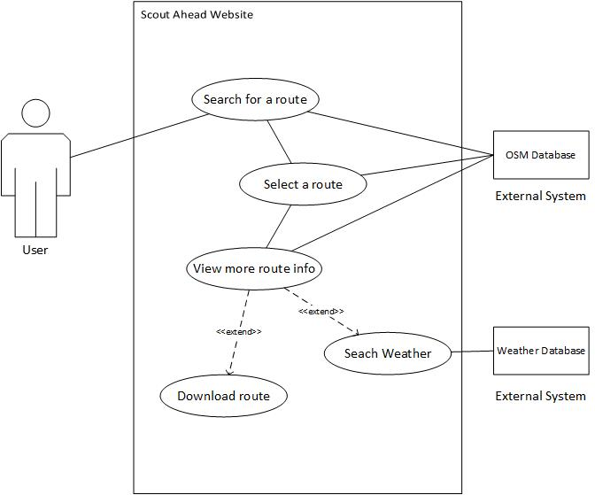

### Description

The following diagram illustrates a typical process when a typical User is using the Scout Ahead website. This is a typical flow of the basic functionality of the website in regard to external parties such as the User and external systems.

## Data Flow Diagram

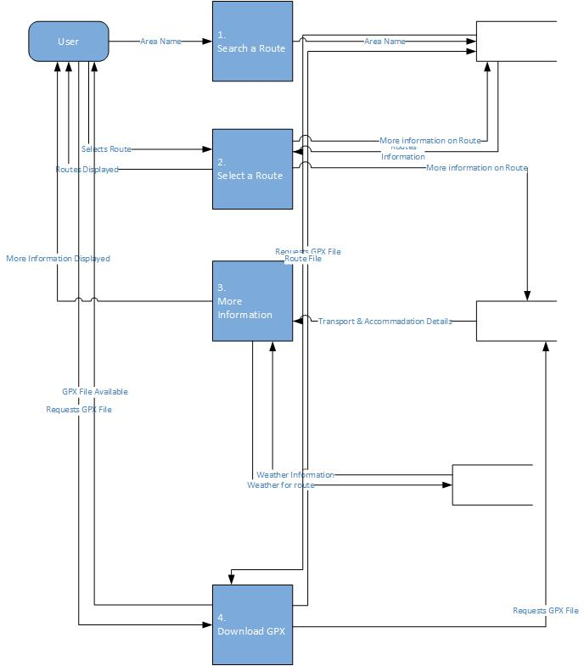

# Preliminary Schedule

## Gantt Design

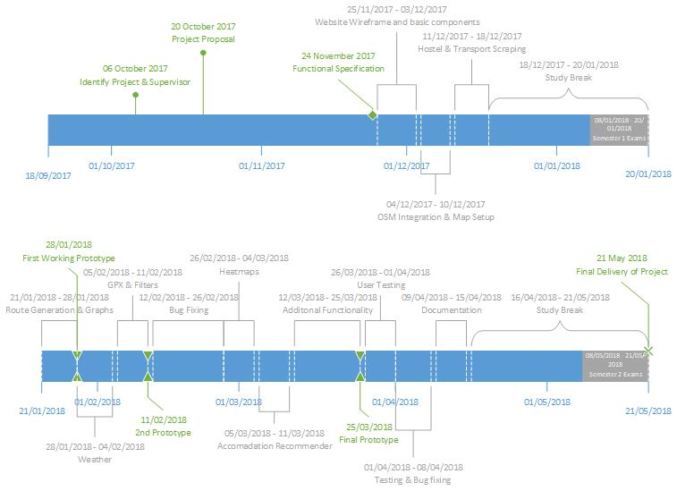

## Proposed Schedule

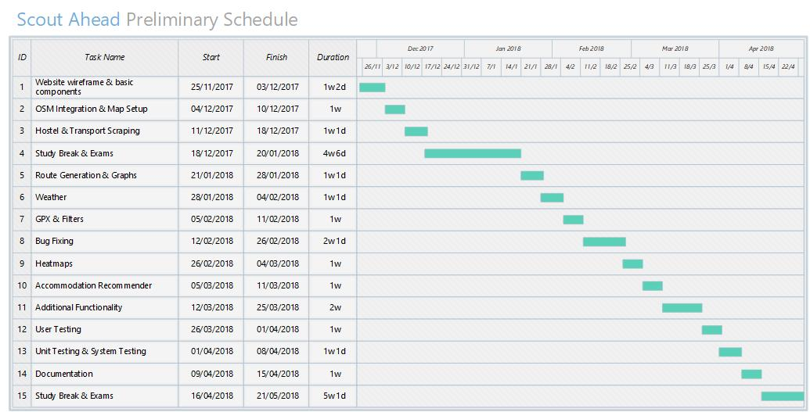

## Description of Tasks

### Website Wireframe and Basic Components

Building the basic wireframe layout of the website with sample text to see how everything looks before moving forward to ensure I won’t have to change the layout once the more technical parts of the website are implemented.   
  
Building the wireframe will mean creating all the empty components and ensuring the website is as responsive as possible before moving forward. This is will also be the time I chose the colour scheme for the website and draw up a logo.

### OSM Integration & Map setup

This will be implementing a simple map that is ready to take in more data like Hostel and transport locations.

### Hostel & Transport Scraping

In the run up to exams I will be scraping websites for Hostel Names and locations, Train Station Names and Locations and Bus Stop Numbers and Locations. As not all websites allow web scraping, this process may be very time consuming to get all the data and have it in a format ready to be used by OSM.

### Study Break & Exams

In the run up to Semester 1 exams, I will be taking time off to focus on my studies.

### Weather

After exams are over I hope to get right back into the project by getting the weather functionality up and running, this will include time for learning the OpenWeatherMap API and how to implement it into my map.

### GPX & Filters

At this point I should have the first Prototype of the website ready. The next stage will be to get the download and filters options implemented. To implement the GPX files I’ll need to be able to retrieve the selected route from the OSM database then convert the route to a GPX file using OpenLayers.   
  
Next, I want to implement filters on the route distance and difficulty, these filters should hide any routes outside the selected parameters. I plan to do this by hiding table rows outside the filters to reduce the number of calls being sent to the OSM Server.

### Bug Fixing

This will be time I have left to polish any pieces of code that took longer than expected to implement or are not yet working as intended.

### Heatmaps

Using heatmaps I hope to highlight the most popular routes and later If I have time to allow user uploaded routes and show which of those are most popular. I plan to use OpenLayers to generate the filters and change the route colour based on the number of times it has been searched/selected, information that will be stored in the Scout Ahead database.

### Accommadation Recommender

The Accommodation Recommender will be implemented as part of the more info tab on the left side of the screen and will show hostels located near the selected route.

### Additional Functionality

Some additional functionality I would like to implement if I have time would be to be setup and host my own version of the OSM database, I know this process is quite difficult and time consuming as it requires a large amount of the processes and packages all of which I am unfamiliar with.

At this stage I also hope to do some site optimisation to reduce the load time of the website.

### User Testing

For testing I plan to send my website to members of Scouting Ireland to try and get their opinion. I hope to write a questionnaire that asks them to do particular tasks and find particular information on the site and to have them rate their experience afterwards.

### Unit Testing & System Testing

I also plan to do some Unit and Boundary tests on the code of my site to ensure all works as intended. Lastly, I plan to do some stress testing to see how my site performs under load.

### Documentation

As there is a large amount of marks going for documentation I plan to spend this entire week on writing the User Manual, Technical Guide and Video Walkthrough.

### Study Break & Exams

Finally I plan to leave these last weeks dedicated to the Semester 2 exams and use the last few days after the exams to refine and correct any mistakes in my Documentation.

# Appendices

## Libraries Used

* Angualr2 - https://angular.io/
* Bootstrap - https://getbootstrap.com/
* OpenLayers - http://openlayers.org/
* OpenGL - https://www.opengl.org/
* OpenStreetMap - https://www.openstreetmap.org/#map=7/53.465/-8.240
* OpenWeatherMap - <https://openweathermap.org/>
* ChartJS - http://www.chartjs.org/

## Website Mockup

### Layout

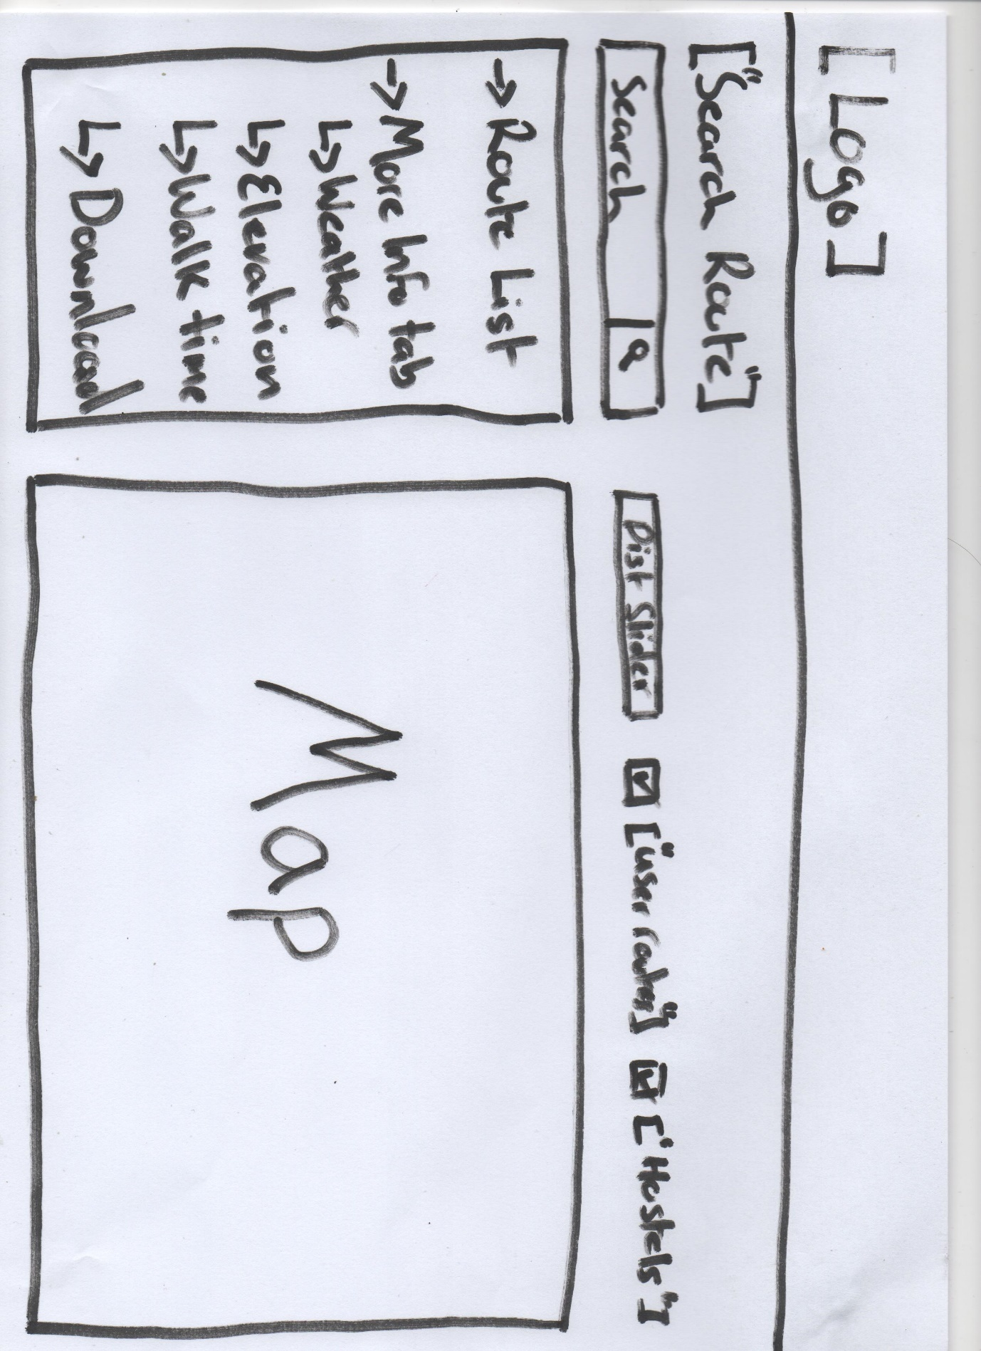

### Map and More Info Panel

